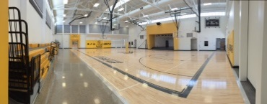

Robert F Kennedy Charter School

4300 Blake Rd., SW Albuquerque, NM 87121 Phone: (505)243-1118 - Fax: (505)242-7444

The Robert F. Kennedy Charter School does not discriminate on the basis of race, color, national origin, sex, disability, or age in its programs and activities and provides equal access to the Boy Scouts and other designated your groups. The following persons has been designated to handle inquiries regarding the non-discrimination policies.

Title IX Coordinator Section 504 Coordinator
Pete Ciurczak, Dean of Students Linda Ortega, Instructional Coach
4300 Blake Rd., SW Albuquerque, NM 87121 4300 Blake Rd.,, SW Albuquerque, NM 87121
(505)243-1118 (505)243-1118

La escuela “Robert F. Kennedy Charter School no descrimina sobre el rais, el origen nacional, el sexo, las discapacidad o le edad en la actividades de sus programas y proporciona igual aceeso a los Boy Scouts y otros grupos designados por usted. Las siguientes persona han sido designadas para manejar consultas con respeto a las politicas de no discriminar.

Title IX Coordinator Section 504 Coordinator
Pete Ciurczak, Dean of Students Linda Ortega, Instructional Coach
4300 Blake Rd., SW Albuquerque, NM 87121 4300 Blake Rd.,, SW Albuquerque, NM 87121
(505)243-1118 (505)243-1118

